**Vector**

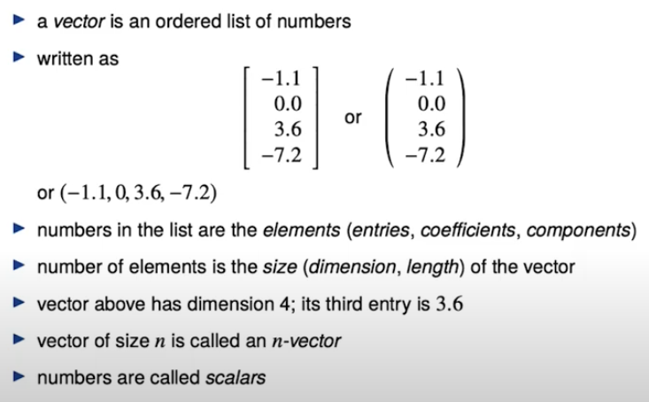

**Symbol:**

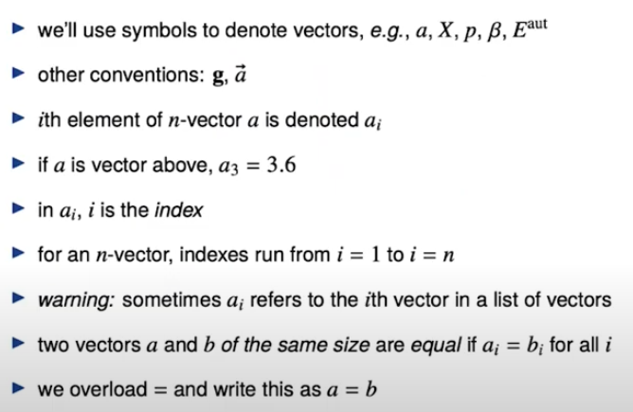

**Block Vector:** the size of block vector is the total of size of its member vector.

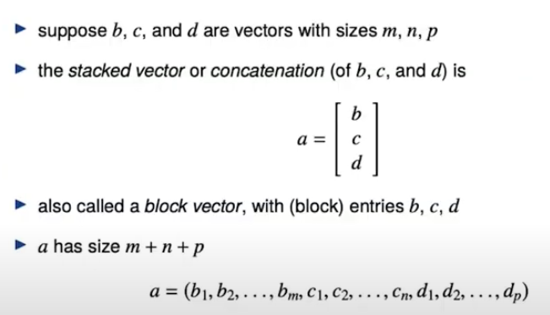

**Zero, Ones and Unit Vector:**

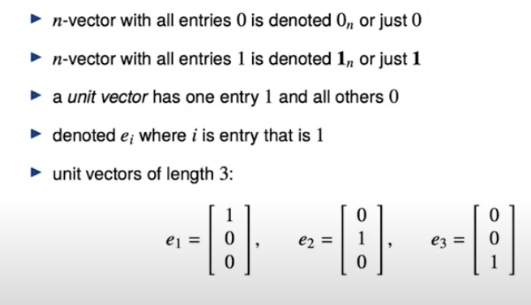

**Sparse Vector:** We can store them in efficient way for example by using some data structure specifying which entries aren’t zero and giving them a value. Also we can operate on them more efficiently.

